Name :- khushal dilipbhai vadher

Roll :- CE151

GitHub Link:-

<https://github.com/khushal-vadher/SDP>

Code test:-

body:  
  
 Padding(  
 padding: EdgeInsets.all(50),  
 child: Text('Hello only padding..padding givien by khushal'),  
  
),

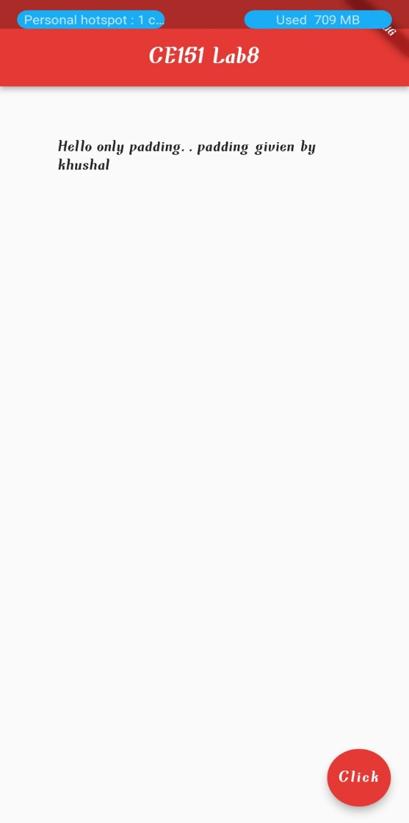

Code Test:-

body:  
Row(  
 children: [  
 Text('HELLO ROW'),  
 FlatButton(  
 onPressed: () {},  
 color: Colors.*purple*,  
 child: Text('Press Me'),  
 ),  
 Container(  
 color: Colors.*cyanAccent*,  
 padding: EdgeInsets.all(30.0),  
 child: Text('inside container'),  
 )  
 ],  
),

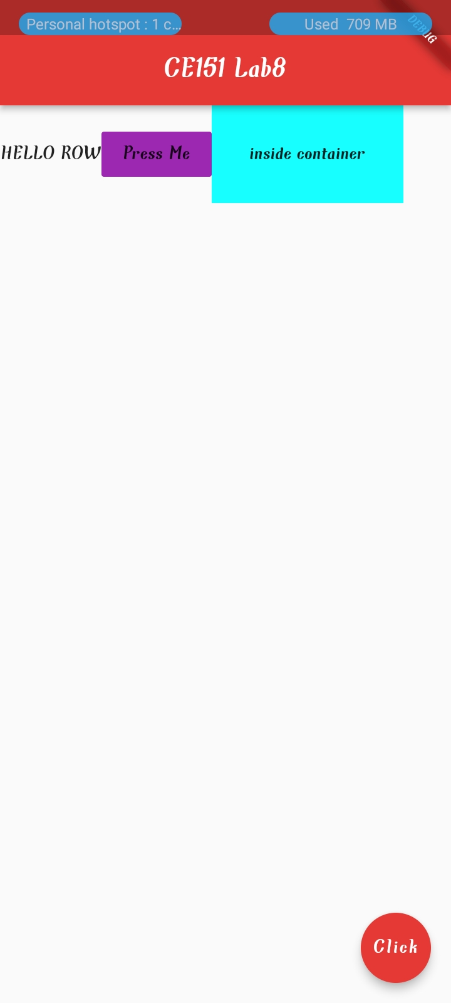

Column Test

body:

    Column(

    mainAxisAlignment: MainAxisAlignment.spaceAround,

    crossAxisAlignment: CrossAxisAlignment.stretch,

    children: [

      Text('HELLO ROW'),

      FlatButton(

          onPressed: () {},

          color: Colors.*purple*,

          child: Text('Press Me'),

      ),

      Container(

        color: Colors.*cyanAccent*,

        padding: EdgeInsets.all(30.0),

        child: Text('inside container'),

      )

    ],

  ),

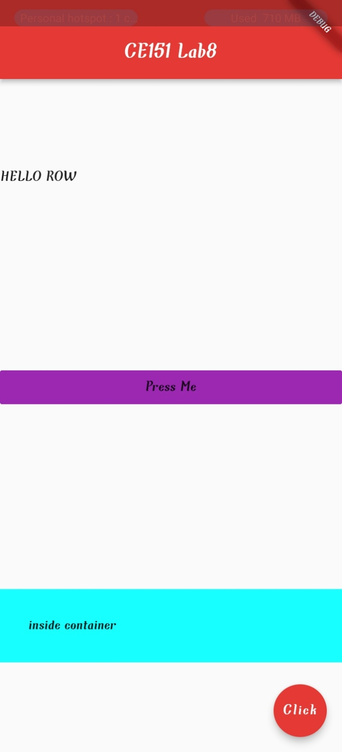

Column change:-

body:

    Column(

    mainAxisAlignment: MainAxisAlignment.center,

    crossAxisAlignment: CrossAxisAlignment.center,

    children: [

      // Text('HELLO ROW'),

      // FlatButton(

      //     onPressed: () {},

      //     color: Colors.purple,

      //     child: Text('Press Me'),

      // ),

      Container(

        color: Colors.*deepOrange*,

        padding: EdgeInsets.all(30.0),

        child: Text('inside container'),

      ),

      Container(

        color: Colors.*limeAccent*,

        padding: EdgeInsets.all(50.0),

        child: Text('inside container 2'),

      ),

      Container(

       color: Colors.*green*[800],

       padding: EdgeInsets.all(70.0),

        child: Text('inside container 3'),

       ),       ],

  ),

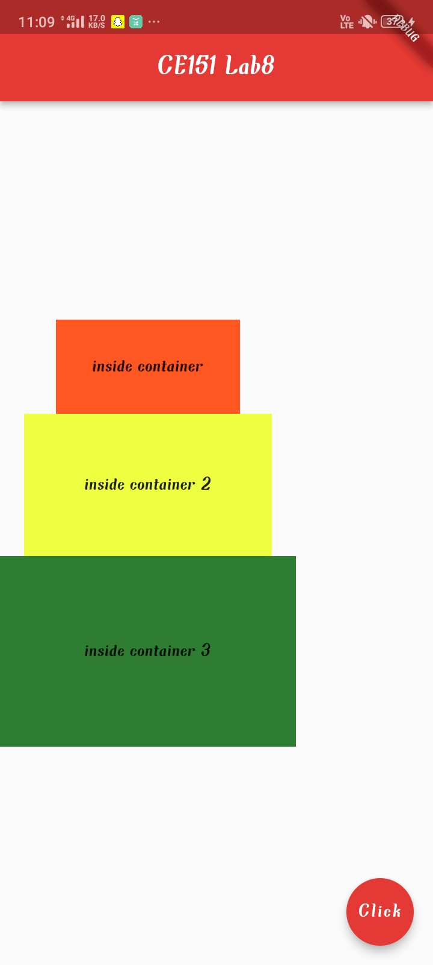

Row And Column :  Test 1

body:

    Column(

    mainAxisAlignment: MainAxisAlignment.center,

    crossAxisAlignment: CrossAxisAlignment.center,

    children: [

      // Text('HELLO ROW'),

      // FlatButton(

      //     onPressed: () {},

      //     color: Colors.purple,

      //     child: Text('Press Me'),

      // ),

      Row(),

      Container(

        color: Colors.*deepOrange*,

        padding: EdgeInsets.all(30.0),

        child: Text('inside container'),

      ),

      Container(

        color: Colors.*limeAccent*,

        padding: EdgeInsets.all(50.0),

        child: Text('inside container 2'),

      ),

      Container(

       color: Colors.*green*[800],

       padding: EdgeInsets.all(70.0),

        child: Text('inside container 3'),

       ),       ],

  ),

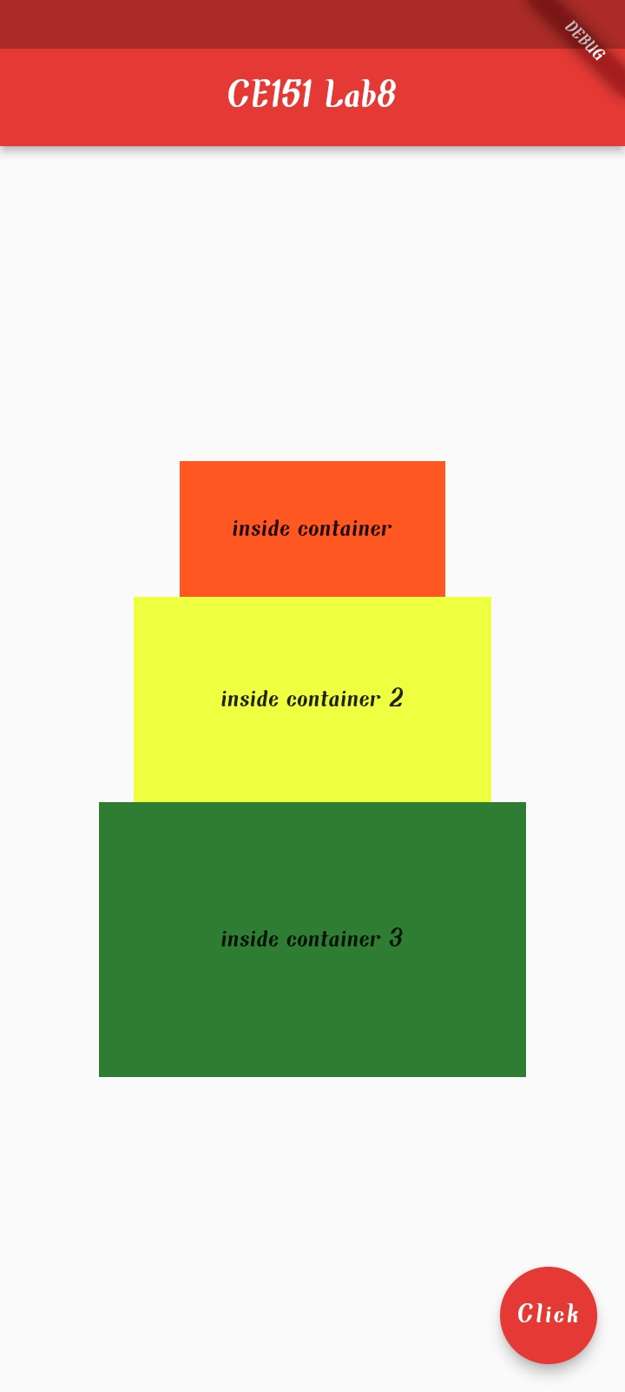

Row And Column :  Test 2

import 'package:flutter/material.dart';

void main() => runApp(MaterialApp(

 home: HomeScreen(),

));

class HomeScreen extends StatelessWidget {

 // const HomeScreen({Key? key}) : super(key: key);

 @override

 Widget build(BuildContext context) {

   return Scaffold(

     appBar: AppBar(

       title: Text(

           'CE025 Lab8'),

       centerTitle: true,

       backgroundColor: Colors.*red*[600],

     ),

     body:

          Column(

         // mainAxisAlignment: MainAxisAlignment.center,

            mainAxisAlignment: MainAxisAlignment.end,

//           crossAxisAlignment: CrossAxisAlignment.center,

            crossAxisAlignment: CrossAxisAlignment.end,

          children: [

            // Text('HELLO ROW'),

            // FlatButton(

            //     onPressed: () {},

            //     color: Colors.purple,

            //     child: Text('Press Me'),

            // ),

            // Row(

            //   children: [

            //     Text('Hello DDU,...   '),

            //     Text('   ...Hello 5th sem students....')

            //   ],

            // ),

            Container(

              color: Colors.*deepOrange*,

              padding: EdgeInsets.all(30.0),

              child: Text('inside container'),

            ),

            Container(

              color: Colors.*limeAccent*,

              padding: EdgeInsets.all(50.0),

              child: Text('inside container 2'),

            ),

            Container(

             color: Colors.*green*[800],

             padding: EdgeInsets.all(70.0),

              child: Text('inside container 3'),

             ),

          ],

        ),

     floatingActionButton: FloatingActionButton(

       onPressed: (){},

       child: Text('Click'),

       backgroundColor: Colors.*red*[600],

     ),

   );

 }

}

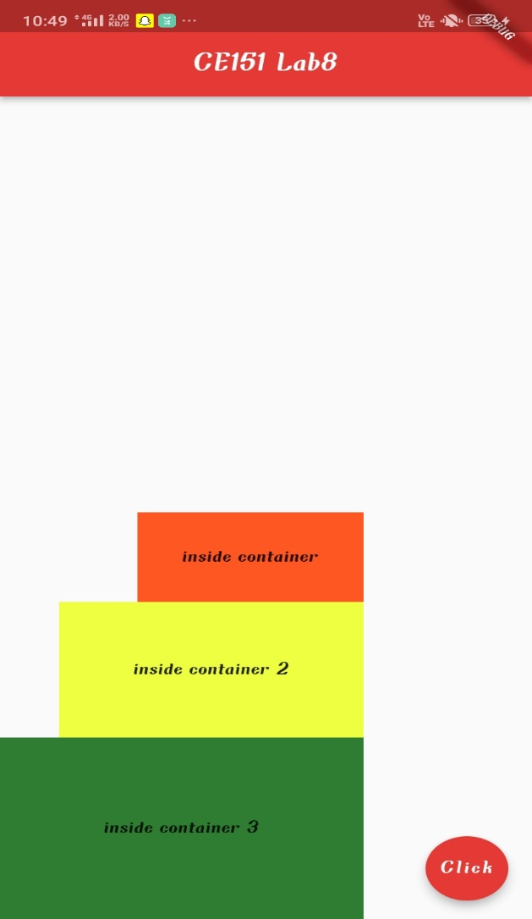

**Final Custom Design :**

import 'package:flutter/material.dart';  
void main() => runApp(MaterialApp(  
 home: FinalTest1(),  
));  
class FinalTest1 extends StatelessWidget {  
// const FinalTest1({Key? key}) : super(key: key);  
 @override  
 Widget build(BuildContext context) {  
 return Scaffold(  
 backgroundColor: Colors.*lightGreen*[200],  
 appBar: AppBar(  
 title: Text('First App'),  
 centerTitle: true,  
 backgroundColor: Colors.*lightBlue*[600],  
 elevation: 0.0,  
 ),  
 body: Padding(  
 padding: EdgeInsets.fromLTRB(30, 40, 30, 0),  
 child: Column(  
 crossAxisAlignment: CrossAxisAlignment.start,  
 children: [  
 CircleAvatar(  
 backgroundImage: AssetImage('assets/dog3.jpg'),  
 ),  
 Text(  
 'NAME: ',  
 style: TextStyle(  
 color: Colors.*grey*[800],  
 letterSpacing: 2.0,  
 ),  
 ),  
 SizedBox(height: 10),  
 Text(  
 'Khushal Vadher',  
 style: TextStyle(  
 color: Colors.*blue*[900],  
 letterSpacing: 2.0,  
 fontWeight: FontWeight.*bold*,  
 fontSize: 20.0,  
 ),  
 ),  
 SizedBox(height: 40),  
 Text(  
 'AGE',  
 style: TextStyle(  
 color: Colors.*grey*[800],  
 letterSpacing: 2.0,  
 ),  
 ),  
 SizedBox(height: 10),  
 Text(  
  
 '20',  
 style: TextStyle(  
 color: Colors.*blue*[900],  
 letterSpacing: 2.0,  
 fontWeight: FontWeight.*bold*,  
 fontSize: 20.0,  
 ),  
 ),  
 SizedBox(height: 50),  
 Row(  
 children: [  
 Icon(  
 Icons.*email_rounded*,  
 color: Colors.*deepPurple*[800],  
 ),  
 SizedBox(width: 12.0),  
 Text(  
 'khushalvadher21333@gmail.com',  
  
 style: TextStyle(  
  
 color: Colors.*brown*[800],  
 fontSize: 16.0,  
 letterSpacing: 1.5,  
  
 ),  
 )  
 ],  
 )  
 ],  
 ),  
 ),  
 );  
 }  
}

Output:-

